**Project Initialization and Planning Phase**

| Date | 09 July 2024 |
| --- | --- |
| Team ID | SWTID1720023141 |
| Project Name | Prediction and Analysis of Liver Patient  Data Using Machine Learning |
| Maximum Marks | 3 Marks |

**Define Problem Statements (Customer Problem Statement Template):**

Accurately diagnosing and predicting liver disease is essential for effective patient care and treatment. Unfortunately, existing diagnostic methods often lack the necessary precision and consistency, resulting in delays and potential errors in identifying liver conditions. These inaccuracies can lead to less effective treatment plans, negatively affecting patient outcomes and quality of life. By leveraging advanced machine learning techniques, we aim to improve the accuracy and reliability of liver disease diagnostics. This enhancement will enable healthcare providers to create more effective, personalized treatment plans, ultimately improving patient outcomes and optimizing medical resource use.

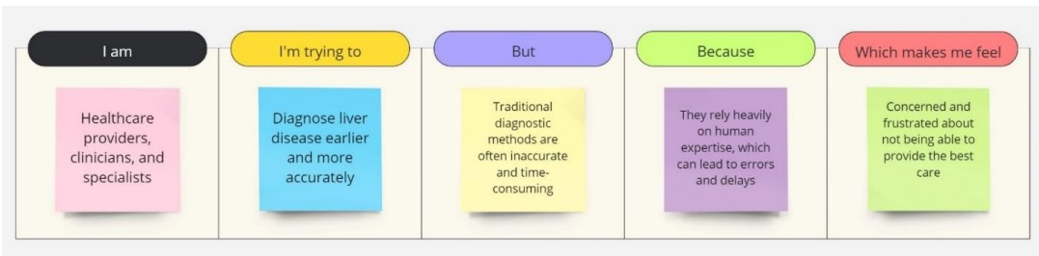

|  |  |  |  |  |  |
| --- | --- | --- | --- | --- | --- |
| **Problem**  **Statement (PS)** | **I am**  **(Customer)** | **I’m trying to** | **But** | **Because** | **Which makes me feel** |
| PS-1 | Healthcare providers, clinicians, and specialists | Diagnose liver  disease earlier  and more  accurately | Traditional  diagnostic  methods are often  inaccurate  and time  consuming | They rely  heavily on  human  expertise, which can lead to errors and  delays | Concerned and  frustrated about not  being able to  provide the best  care |